**How to view these scenes**

The visualization scenes, which will contain a dark blue color on the transcript text, consist in:

1. a ‘before/during request’ snapshot of the participant and display from the rear camera

2. an ‘after request’ snapshot of the participant and display from the rear camera

3. Optional: additional snapshots showing gestures or other relevant changes in participant behavior or screen state

4. The transcript which roughly covers the content of their request. Note: this is not a strict delineation of the boundaries between actionable utterances and think-aloud, which might be used in a natural language processing study. This is the portion of the transcript which most directly captures the participant’s request. For nlp related inquiries, consult the papers referenced at the end of this document.

5. Optional: Additional think-aloud which is relevant to this scene

6. The visualizations produced by the mediator. These are also available, coded by request number, in the visualization folders associated with the participant

Note: occasionally, visualizations were too large to fit within the scene, and were excluded, with a note to reference the visualization folder

7. Optional: additional notes on the scene.

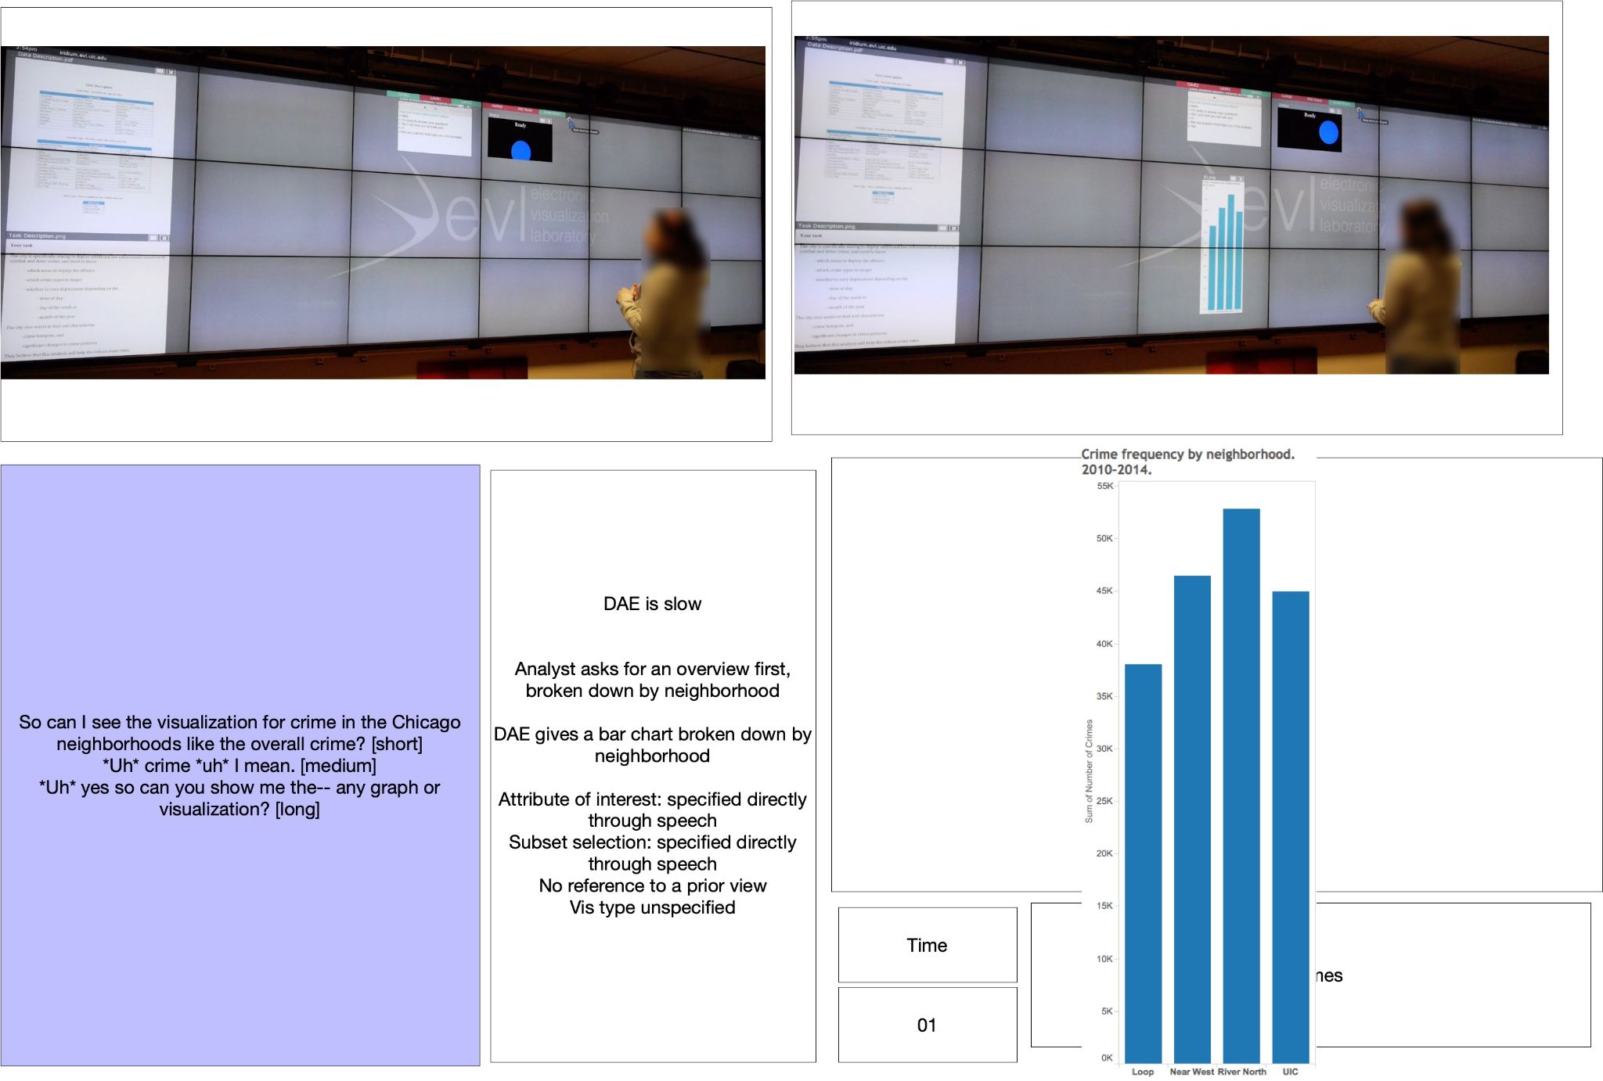

The non-actionable scenes, distinguishable by the light blue text, will sometimes show the participants movement and mid-air gestures.

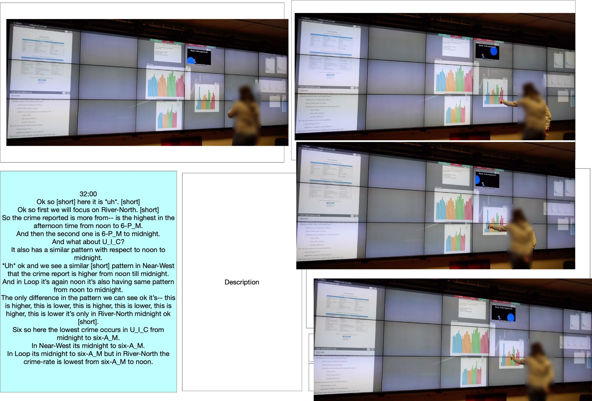

**Scene order:**

Scenes are ordered 1-N. These scenes are in temporal order, except for the following situation:

Participants frequently posed a request, and while they waited for the response, either remained silent or expressed insights about the views that were already present on screen from prior requests. Then they got the response.

So the structure in the session is :

Ask for new views of the data

Wait, or discuss views already onscreen

Receive new views

Discuss these views

Pose a new visualization request.

We would divide these actions into scenes as follows:

Scene 1: Ask for new views of the data

Scene 2: Wait, or discuss views already onscreen

Scene 1: Receive new views (note this is depicted in scene 1, not after scene 2)

Scene 3: Discuss these views

Scene 4: Pose a new visualization request

The request and response are always grouped together in a scene, and intervening think-aloud discussion is isolated in a separate scene. We marked these in the comments boxes in non-actionable scenes.

Other rare instances of a-temporal ordering are noted in the scene.

**Evolution of scene creation:**

The scenes evolved over the analysis. Many of the early scenes contained notes, and scenes created later, at a point where the analysis had a tighter focus, often did not. Initial attempts were made to capture time stamps and log visualization numbers, but this continue, as it was not relevant to this analysis and was already covered in other papers.

Some participants had long think-aloud portions of their transcript, and once we knew we were not focusing on think about for this paper, we sometimes captured fewer screenshots for these participants.

**Errors and scenes:**

At times the mediator would respond to the request with a view that contained an error, this error may be corrected later, and this might alter the order of scenes. In each case, we attempted to make the order of events clear.

**Visualizations and chat transcripts:**

Visualizations are numbered by request. Requests with multiple responses are distinguished by -N. For example, if 2 responses were provided to the first request, we numbered these ’01-1.png’ and ’01-2.png’.

If a visualization was provided as a correct, it preserved the first or first two numerals and we added a -2 to the end, to indicate that it was a revised version. For instance, a correction to 03.pg would be numbered 03-0-2.png. A correction to 04-1 would be numbered 04-1-2.png .

Chat transcripts were stored and are available in the chat transcript folder.

**Coding scheme overview:**

Our coding scheme is in an excel spreadsheet in this repository.

Note- we have hidden non-visualization request rows in the spreadsheet, because our focus was on visualization requests in our coding scheme. So non-visualization request rows and scenes are not addressed in our coding scheme.

Column A: Participant identifier

Column B: Scene number

Column C: Description of the scene

Column D: Is the scene a visualization request, or a layout request, or a non-actionable request

Column O,P,Q,R: Select one for each request: Direct request, referential request, selection request, and unclear.

Column T, U, V, W, X: Just for Direct requests, select one of Target, Browse, Compare, Complex

Column Z, AA, AB: For referential requests, select how many views are targeted (one or many) how many operations are expressed (one or many) and how many outcomes are produced (one or many)

Column AD: What the referential pivot changes (eg. change of filter). Not used in our analysis

Column AF, AG, AH, AI: Just for Referential requests, select one of Target, Browse, Compare, Complex

Column AK, AL, AM, AN: Just for Referential requests, select one of Target, Browse, Compare, Complex

The remaining columns are not used in our analysis.

**Notes on coding and the coding document:**

We focused in our coding scheme on the participant request and how they utilized views on screen, not on how the mediator responded to this request. However, the description column will include information about how the mediator (who we nicknamed the ‘DAE’ for ‘Data Analysis Expert’) responded, because these descriptions were created early in our analysis process and were an attempt to summarize each scene in full.

We hid non-actionable scenes and requests to modify the layout in the excel spreadsheet, as these were not the focus of our analysis. As the analysis evolved, we were less likely to fill in the content of the think-aloud in the excel sheet, because it was not relevant to this analysis.

Codes are colored to indicate the relevant columns to fill in- distinguishing direct, referential and selection actions. There are some columns that contain notes which we retained, but which were beyond the scope of this study.

**Coding process:**

*Decision 1. Was this scene a visualization request or another kind of request:*

The main criteria here was to look at whether they explicitly asked to create views or explore a new portion of the data attribute space in their speech.

In some cases the mediator did not register that a request was posed, for instance if someone asked a second request while the mediator was composing a response. These were not included in the analysis, because the request might be repeated, or might seem irrelevant as views came in.

*2. Direct vs Referential vs Selection*

A complete description of these requests is provided in the paper, however, we add some details about how we divided these requests into these categories.

Overview:

* Direct requests are ones that appear to make no reference to existing views on screen.
* Referential requests duplicate and pivot existing templates, conserving either the subset of the data in the filter for the target view or the data attributes.
* Selection requests isolate one entity or region from the view, and ask for new views to drill down into that region.

There are some complexities in assigning these labels.

A. Reference and selection are not always explicit.

An explicit referential request would use a form of ‘can I see this (pointing), but with x’. Other times, participants would underspecify their request in a way that clearly assumed the mediator would use the existing view or views as a default starting point for their new request. For instance they might be looking at a view of thefts and say ‘now can I see assault?’ We initially divided the explicit and implicit cases, but found this to be complex.

We opted to focus on whether the participant posed their request in a way where completing the request required some reference to existing views, as occurs when a participant underspecifying the intended template, data attribute or filter.

This distinction is subtle and was the subject of much consideration, and there are further considerations we include below.

B. Are repeated uses of a single filter criteria a referential request?

Another complicated case: Frequently participants would isolate a filter of interest from the data and ask many questions about this region of the data.

A good example of this pattern is in participant 8. This participant asked a series of questions about thefts. We had to decide- should we treat all of these as referential requests, because they are conserving a filter across many requests? Given that these requests were not accompanied by a mid-air gesture or clear ‘keep this filter, but now…’, we needed to make a decision.

In this case, we opted to code these requests as direct, not referential. We felt that referential requests should be reserved for cases where a view is used as a shortcut for conserving a complex template or filter, and that the conservative approach to this situation is to focus on these cases as referential, because lumping all these cases together as referential would dilute the category.

If a participant explicitly referenced a view to conserve it’s filter, particularly if they referenced a complex filter (eg. thefts in 2014 on Mondays) by saying ‘can I see this, but…’, we did label this as referential, because it was a clear case of duplicating and pivoting a view. However, if a participant referred to thefts frequently, but made no explicit reference, these were coded as direct.

The result of this is to diminish the number of referential ‘browsing’ actions, which would be the label supplied for explicit cases of this type.

C. Once a participant made a selection, if they use the selected region again, is it another selection?

Once a subset had been selected, if it was used again we did not code it as selected. This was the subject of discussion, but we wanted to avoid over-labeling reference and selection actions, to isolate clearer cases.

D. If a participant noticed that theft was the most common crime type, and then 30 minutes later remember this fact and ask a question just about theft, when this view was no longer active, is it a selection or a referential request?

We did not code these as ‘selection’ actions or referetial, because they weren’t acting on a view currently active to express their intentions, but recalling an insight.

*3. Target, Browse, Compare, Complex, for direct requests*

For a direct request, we looked at the number of subsets of the data and the number of data attributes enumerated by the participant in their request.

Note- we did not factor in the mediator response, but just how the participant posed their request.

Model targeted request : “Can I see theft by year”

Model browse request: “Can I see Loop crimes by crime type and neighborhood, in separate views.”

Model comparison request: “Can I compare Loop and Near West crime by crime type?”

Model complex request: “Can I see Loop and Near West by crime type and year”

However, there is complexity that needs to be considered.

If someone directly indicates that they want to combine enumerated subsets into a single filter, such as “Can I see 2010 and 2011 together, by neighborhood?”, this would not be classified as a comparison request, but as a targeted request.

If someone asked for “UIC thefts on Mondays”, this is a single subset of the data, and is classified accordingly.

If someone asks for “Statistics about the Loop”, we felt they wanted to browse multiple data attributes with respect to the listed subset (Loop), and we labeled these requests as ‘browse’.